Town of Ocean City Work Session of Rental Inspections

What is the Rental Inspection Program?:
With the implementation of Ocean City’s proactive rental inspection program, there have been several instances where property owners saw a reduction in their permitted occupancy.
Reductions in occupancy have occurred in both the R-1, where occupancy is calculated at two people per bedroom plus two, and other zones, where occupancy is calculated by a square footage measurement.
This program is very recent, beginning only a year ago. It is a proactive inspection program, where owners with a rental license can expect one inspection every five years. The set of inspection criteria can be found here.

When:
Tuesday, May 12th. 1PM.
Where:
301 Baltimore Ave, Ocean City Maryland, 21842.

What’s on the Agenda?
Several changes to existing law are being proposed next week to better detail occupancy in the town.
One proposed change is as follows:
“Every living room and dining room combined shall contain not less than 120 square feet. Every bedroom shall contain not less than 70 square feet and every bedroom occupied by more than one person shall contain at least 40 square feet of floor area for each occupant thereof. Any bedroom that contains a closet with a minimum size of two feet by five feet or larger will be given a ten-square-foot maximum allowance towards the total calculation of the bedroom area.
Notwithstanding the above, a dwelling unit, except efficiency units which are governed by Section 404.6, shall be allowed an additional two (2) occupants.
No dwelling unit shall be occupied by more occupants than permitted in this chapter.”
Below you will see the current law for calculating occupancy and the proposed new calculation:
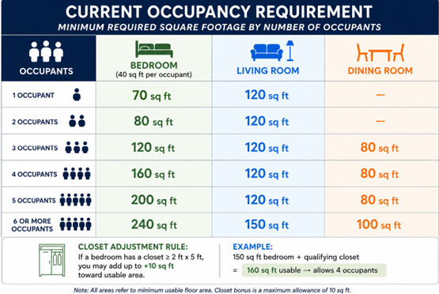
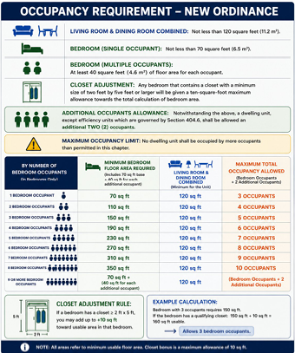

There is also an ordinance to amend the local changes to the 2021 International Property Maintenance Code to allow for an additional two occupants per dwelling unit and an ordinance to revise the Business License application process, and the enforcement powers of the City Manager regarding Business (rental) Licenses.
To view the entire agenda, click here.

